36.28: First-order: 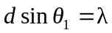
Fourth-order: 